NOTICE OF FARMINGTON FIRE

PROTECTION DISTRICT BOARD VACANCY
Pursuant to California Government Code Section 1780
Notice is hereby given that one (1) vacancy exists on the Board of Directors of the Farmington Fire Protection District.
The Board of Directors intends to fill this vacancy by appointment at a special meeting scheduled for:
Date: Wednesday, April 8, 2026
Time: 7:00 p.m.
Location: Farmington Fire Department
25474 E. Highway 4,
Farmington, CA 95230

Individuals interested in being considered for appointment must be registered voter in San Joaquin County, California and reside within the Farmington Fire Protection District boundaries.
Applicants must submit a USPS certified letter of interest to:
Farmington Fire Protection District, P.O. Box 25, Farmington, CA 95230
Letters must be received no later than 5:00 p.m., Tuesday, April 7, 2026.
So ordered by the Farmington Fire Protection District Board of Directors, March 23, 2026.
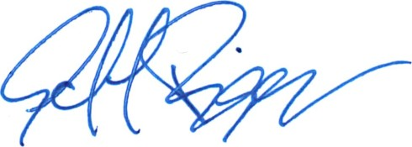
Jeff Briggs
Board President
Farmington Fire Protection District

